**Identifying and Classifying quadrilaterals**

Did you know that the shapes we see every day like the page of a book, painting, photo frames, TV screens, etc are quadrilaterals? There are different types of quadrilaterals with unique characteristics. In this article, let’s explore the most common types of quadrilaterals and learn how to identify them.

**What is a quadrilateral?**

A quadrilateral is a four-sided polygon. All quadrilaterals have the following set of properties:

1. It has 4 sides, vertices, and angles.
2. The sum of the four interior angles is 360°.
3. The perimeter of a quadrilateral is the sum of all four sides.

**The Parallelogram**

A parallelogram is defined as a quadrilateral with parallel opposite sides.

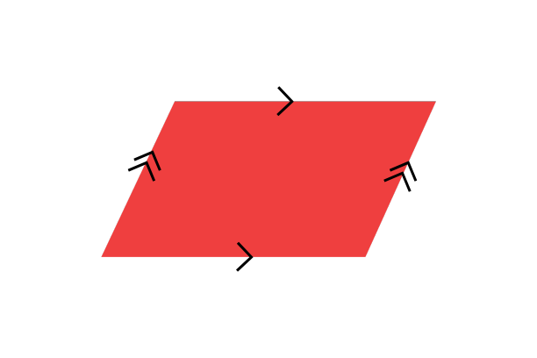

Apart from having characteristics of any quadrilateral, parallelograms have the following unique properties:

* Opposite angles are equal
* Opposite sides are equal in length
* The diagonals of a parallelogram bisect each other

The above diagram illustrates a general parallelogram, but there are other parallelograms with special features that are classified separately. The special parallelograms are:

* **The Rhombus** - The rhombus closely resembles the parallelogram illustrated earlier, but the unique feature that makes the rhombus special is that all four sides are of equal length.
* **The rectangle** - The rectangle is unique because of its interior angles. The interior angles of a rectangle are all right angles. Note that, rectangles are a special type of parallelogram, hence have all the characteristics of a parallelogram mentioned above.
* **The square** - The square is special because it is a regular polygon, i.e all of its sides and interior angles are equal. A square is also a special type of parallelogram as it is a polygon with parallel opposite sides.

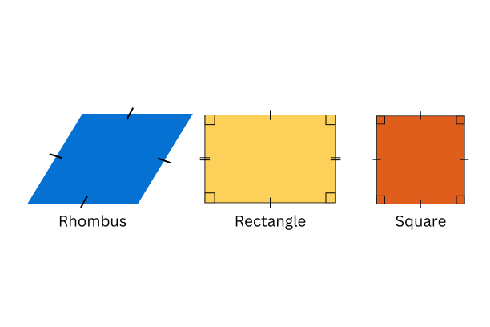

**The Trapezoid**

The presence of a single pair of parallel edges can uniquely identify a trapezoid/trapezium. Following are some variants of trapezoids.

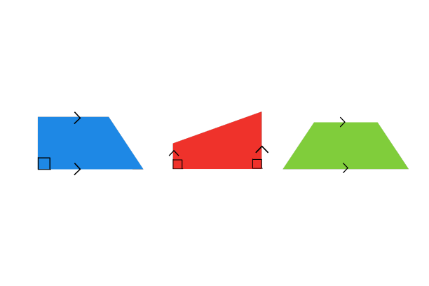

The isosceles trapezoid shown below is a special variant of the trapezoid where the non-parallel pair of sides are equal in length.

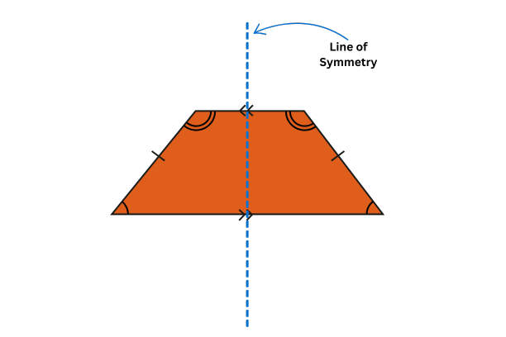

**The Kite/Diamond**

The kite (or diamond) shape resembles both a kite and a diamond. It's important not to confuse a kite with a rhombus. A key difference is that a kite does not have any parallel sides. One important property of a kite is that it has two pairs of adjacent sides that are equal in length, resulting in one line of symmetry.

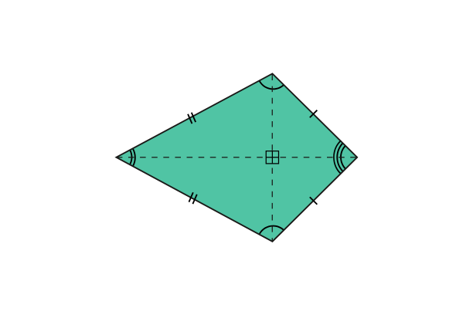

**Summary of Properties**

| **Property** | **Parallelogram** | **Rhombus** | **Square** | **Rectangle** | **Trapezoid** | **Kite** |
| --- | --- | --- | --- | --- | --- | --- |
| **Opposite sides are parallel** | Yes | Yes | Yes | Yes | No | No |
| **Opposite sides are equal** | Yes | Yes | Yes | Yes | No | No |
| **Opposite angles are of equal measure** | Yes | Yes | Yes | Yes | No | No |
| **All sides are equal** | No | Yes | Yes | No | No | No |
| **All angles are of equal measure** | No | No | Yes | Yes | No | No |
| **Lines of Symmetry** | 0 | 0 | 4 | 2 | 0 | 1 |